4/26/2025

## Group ( 1 )

1. **Hossameldin Hassan Abdelhady**
2. **Germine Yousry Abdelwahab**
3. **Ayatollah Ahmed Mahmoud**
4. **Salma Kamel Abdelaziz**

**Technical Instructor : Eng. Ahmed Alaa**

**Group : Alx2_Dat1_G1**

**Google Data Analyst Specialist**

## Sales Analysis Project

## Sales Analysis Project

## Prestige Cars Sales Analysis Project

## Sales Analysis Project

## Sales Analysis Project

Table of Contents

1. Project Planning & Management 2

1.1 Project Overview 2

1.2 Objectives 2

1.2.2.Key Analytical Questions for Prestige Cars Sales Analysis 3

1.3 Scope 3

1.4 Project Timeline 5

Phase 1: Data Collection 6

Phase 2: Exploratory Data Analysis, Data Cleaning , Data Processing & Transformation 6

Phase 3: Descriptive and Diagnostic Analysis ( Python ) 10

Phase 4: SQL Database Integration 21

Phase 5: Visualization and Reporting 27

Phase 6: Final Presentation & Submission 30

1.5 Task Assignment& Roles 30

1.6 Risk Assessment & Mitigation 30

1.7 KPIs (Key Performance Indicators) 30

2. Literature Review 31

2.1 Research Background 31

2.2 Feedback & Evaluation 31

2.3 Suggested Improvements 31

3. Requirements Gathering 31

3.1 Stakeholder Analysis 31

3.2 User Stories & Use Cases 32

3.3 Functional Requirements 32

3.4 Non-functional Requirements 33

4. References 33

### 1. Project Planning & Management

### 1.1 Project Overview

The Prestige Car Sales Project is designed to analyze historical and current sales data to uncover trends, support data-driven decision-making, and maximize revenue potential. This project focuses on transforming raw sales data into meaningful insights through systematic data processing, storage, and visualization.

**Components of The Project Include:**

* **Data Cleaning , Processing and Analysis**

Utilizing Python libraries such as Pandas and NumPy to clean, transform, and prepare the sales dataset for analysis.

* **Interactive Data Visualization**

Developing insightful and dynamic dashboards in Power BI to visualize key performance indicators (KPIs), sales trends, and regional performance for strategic business review.

* **SQL Database Integration**

Migrating structured data from Excel files into a relational SQL database, enabling scalable storage, efficient querying, and improved data integrity.

### 1.2 Objectives

The project aims to apply both descriptive and diagnostic analytics to deliver valuable insights from sales data. These insights will inform business strategies, improve forecasting accuracy, and enhance overall operational efficiency.

**1.2.1.Specific objectives include:**

* **Analyze Sales Trends Over Time**  
  Understand overall sales patterns and profit variations through time-series analysis.
* **Identify High-Performing Products and Customer Segments**Diagnose key revenue drivers by analyzing product performance and customer demographics.
* **Improve Demand Forecasting and Inventory Management**  
  Use historical data to enhance cost and revenue control and meet market demand more effectively.
* **Develop Interactive Dashboards**  
  Enable real-time exploration of sales data using dynamic, user-friendly visualizations in Power BI.

### 1.2.2.Key Analytical Questions for Prestige Cars Sales Analysis

**Descriptive Questions (What happened?)**

* **What are the total sales ,cost and profit over time?**
* **Which car’s categories generates the highest sales and profit margins?**
* **Which car models generate the highest sales?**
* **Which car’s make country generate the highest sales and profit margins?**
* **Which car colors are generating the most sales ?**
* **Who are our top customers or customer segments?**
* **Which regions or locations have the highest sales and profit margins?**

**Diagnostic Questions (Why did it happen?)**

* **Why did profit decrease in 2017 ?**

**By answering these questions, the project will support decision-makers in making informed, strategic choices based on trends and data forecasts.**

### 1.3 Scope

**1.3.1 Data Coverage**

* **Time Period:** Sales data from 2015 to 2018 (4 years analysis).
* **Geographical Coverage:** Sales across EMEA (Europe, Middle East, Africa), North America, and others.
* **Product Range:** Luxury car brands (Ferrari, Porsche, Aston Martin, Bentley, Jaguar, etc.).

**1.3.2 Key Metrics Analyzed**

|  |  |
| --- | --- |
| **Category** | **Key Metrics** |
| **Sales Performance** | Total sales revenue, units sold, best/worst-selling models |
| **Profitability** | Gross profit, profit margin, discount impact, cost breakdown (repairs, transport, parts) |
| **Customer Insights** | Top customers, repeat buyers, regional sales distribution |
| **Inventory & Pricing** | Stock turnover, pricing trends, color preferences, model-wise demand |
| **Time-Based Trends** | Yearly sales patterns, seasonality effects |

**1.3.3 Deliverables**

* **Data Cleaning & Processing Report (Python)**

Handling missing data, outliers, and inconsistencies.

Feature engineering (e.g., profit margin calculation, time-based aggregations).

* **Exploratory Data Analysis (EDA)**

Statistical summaries, correlation analysis, trend identification.

* **Interactive Power BI Dashboard**

Sales performance dashboard.

Profitability heatmaps.

Customer segmentation visuals.

Inventory optimization recommendations.

* **Business Recommendations**

Pricing strategy adjustments.

Inventory management improvements.

Regional sales expansion opportunities.

### 1.4 Project Timeline

To ensure the smooth execution of the project, we created a detailed timeline based on the phases of data analysis and presentation. The available duration is distributed as follows:

|  |  |  |  |
| --- | --- | --- | --- |
| **Task** | **Start Week** | **End Week** | **Duration (Weeks)** |
| **Data Collection** | **1** | **2** | **1** |
| **Data Cleaning , Preprocessing & Transformation** | **2** | **3** | **1** |
| **Descriptive and Diagnostic Analysis** | **3** | **5** | **2** |
| **SQL Database Integration** | **5** | **6** | **1** |
| **Visualization and Reporting** | **6** | **7** | **1** |
| **Final Presentation & Submission** | **7** | **8** | **1** |

### Phase 1: Data Collection

**Tools :** Excel

**Source:**

Excel file from <https://github.com> / database for data analyst by Adam Aspin book

**Data Coverage**:

351 records of car sales with +30 columns including: (sales, inventory, customer, financial metrics). From (2015–2018).

**Data Description**:

Key Fields:

* Sales details (ID, date, price, discounts)
* Vehicle information (make, model, color, costs)
* Customer data (name, location)
* Financial metrics (profit, profit percentage)
* Sales data

### Phase 2: Exploratory Data Analysis, Data Cleaning , Data Processing & Transformation

**Tools :** Python

1. 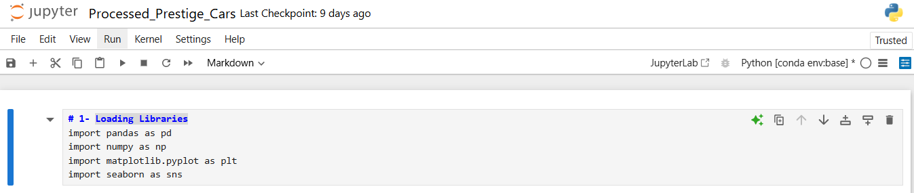**Loading Python Libraries That Support Data Cleaning, Transformation, Visualization, and Working With Database.**
2. **Loading Excel File and Connecting With Python**

1. **Exploratory Data Analysis to Explore, Visualize, and Better Understand Dataset Before Doing Deeper Analysis.**

* **Creating Data Frame**
* **A screenshot of a computer

  AI-generated content may be incorrect.View first few rows**
* 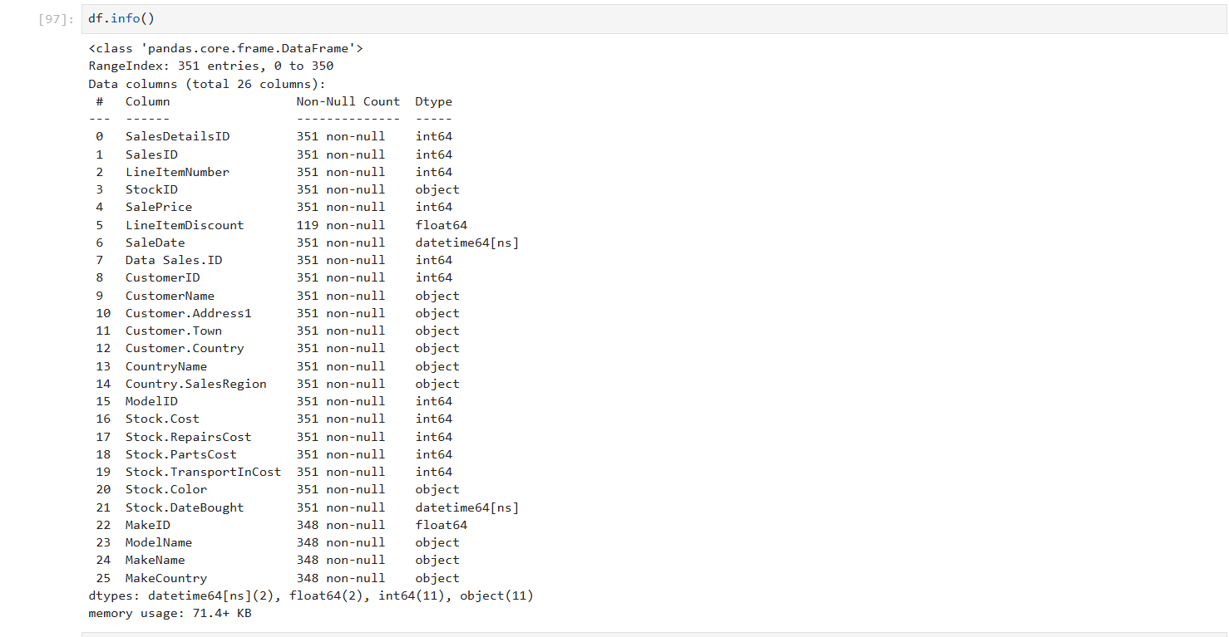**General information about the dataset**
* 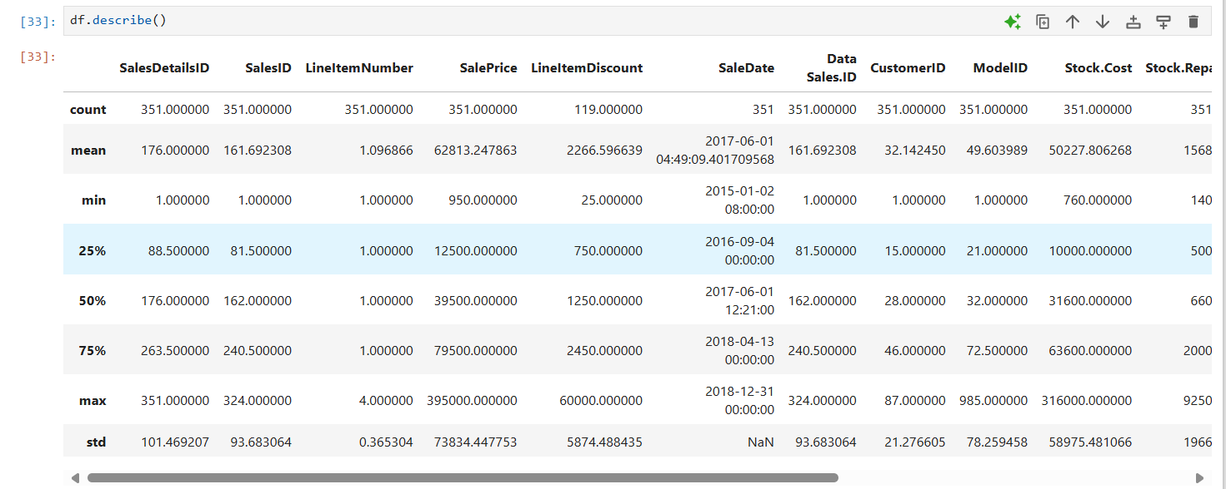**Get descriptive statistics for numerical columns**
* **A white screen with a black border

  AI-generated content may be incorrect.Check for missing values**
* **Check for duplicate records**

1. **Data Cleaning to Handle Missing Values, Remove Duplicates, Fix Formatting, and Correct Inconsistencies.**

* 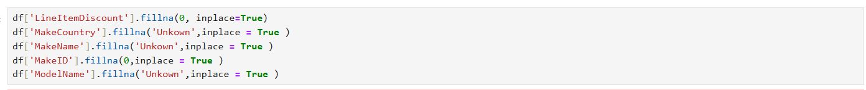**Handling Missing Values**

1. 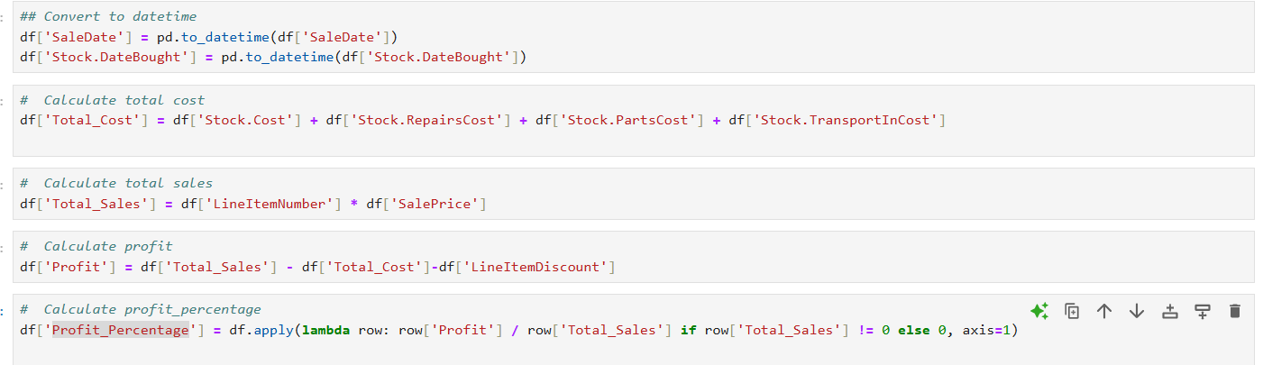**Data Transformation & Processing** **to Convert dates and Creating new columns ( Total Sales , Total Cost , Profit & Profit Percentage )**

### Phase 3: Descriptive and Diagnostic Analysis ( Python )

**Tools :** Python

**Descriptive Questions (What happened?)**

* **A graph with numbers and lines

  AI-generated content may be incorrect.A white rectangular object with text

  AI-generated content may be incorrect.What are the total sales ,cost and profit over time ?**

**Answer :**

* **Steady Growth in Total Sales**

Sales increased consistently from 1.56 million in 2015 to a peak of 8.28 million in 2018. (This reflects a strong upward sales trend, with more than a 5x increase over four years.)

* **Cost of Goods Sold (COGS)**

Total costs increased from 1.22 million in 2015 to 4.2 million in 2016 then increased to 6.7 million in 2017 then decreased to 6.61 million in 2018. (This indicates consistent operational scaling to meet rising demand.)

* **Profit Trends and Fluctuations**

Profit grew significantly from 114K in 2015 to 470K in 2016, marking the highest year-on-year growth.

However, in 2017, despite higher sales, profit declined to 343K due to increased costs in 2017.

In 2018, profit recovered to 464K, showing signs of operational efficiency and margin improvement.

* **A screen shot of a graph

  AI-generated content may be incorrect.A screenshot of a computer

  AI-generated content may be incorrect.Which car’s categories generate the highest sales and profit margins?**

**Answer :**

**Top Performing Car Category by Total Sales:**

Ferrari leads with $6.04 million in total sales, followed by Aston Martin at $5.81 million. These two brands significantly outpace others, showing a strong presence in the market.

Jaguar and Lagonda represent the lowest sales at $950K and $218K, respectively, indicating relatively weaker market performance.

**Profit Contribution by Car Category:**

Bentley stands out with the highest profit of $431K, despite having slightly lower sales than Ferrari. This indicates that Bentley is not only selling high-priced vehicles but also maintaining healthy margins.

Ferrari, while leading in total sales, generates $417K in profit, maintaining solid profit despite slightly lower margins compared to Bentley.

Porsche and Lagonda show significantly lower profits, with $20K and $15K respectively, which could be attributed to either lower sales or higher production and operational costs.

**Profit Margins (Profit Percentage):**

Bentley again leads in terms of profit margin, achieving 23.97%, suggesting that the brand is able to generate substantial profit relative to its sales, likely due to premium pricing and efficient cost management.

Noble follows with a relatively high 21.69% margin, indicating strong profitability despite modest sales.

On the other hand, Porsche and Lagonda have very low profit margins at 5.01% and 10.13%, respectively. This suggests that these brands might be facing challenges in maintaining profitability, possibly due to high operational costs, marketing, and lower-priced models.

* **Recommendations:**

**Bentley and Ferrari are the top contenders in both sales and profit, but Bentley's higher profit margin suggests better overall profitability. Strategies that can be considered for Ferrari would include improving operational efficiency or exploring pricing strategies to enhance margins.**

* **Noble, despite its lower sales, demonstrates impressive profitability, and this could be attributed to niche markets or high-end models. It may be worth investigating whether similar strategies can be applied to other brands like Porsche or Lagonda to improve profitability.**
* **Brands like Porsche and Lagonda, which are underperforming in both profit and margin, may benefit from a detailed cost analysis, reviewing production costs and exploring ways to either increase sales or reduce operational expenses.**

**• Which car models generate the highest sales?**

**Answer :**

* **Top Sellers**

Bugatti 57C leads all models with $1.69 million in total sales — a clear favorite among customers, likely due to its luxury appeal and strong market positioning.

Aston Martin Virage follows closely with $1.56M, reinforcing the brand’s prestige and customer loyalty in the high-end segment.

Ferrari 355 ($1.35M), Aston Martin DB6 ($1.12M), and DB9 ($1.08M) also rank high, confirming the dominance of British and Italian sports/luxury cars in sales performance.

Models like the Ferrari Enzo ($1.02M), Diabolo ($905K), and Testarossa ($870K) confirm the high demand for exotic sports cars.

Rolls Royce Phantom and Silver Seraph also make the list, highlighting a niche but powerful luxury car segment.

Although models like the Vanquish ($361K) and Silver Seraph ($359K) generate lower sales compared to top sellers, they still reflect meaningful demand in the ultra-luxury segment.

* **Recommendations:**

**Prioritize stocking and marketing top performers like the 57C, Virage, and DB models generate the highest ROI.**

**Highlight the appeal of exotic and collector cars (e.g., Enzo, F50, F40) through targeted campaigns for enthusiasts.**

**Monitor mid-tier performers for pricing optimization or bundling strategies to boost their market traction.**

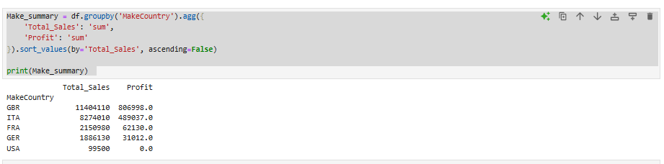**• Which car’s make country generate the highest sales and profit margins?**

**Answer :**

GBR dominates both in sales volume and profit generation, indicating high customer demand and strong profit margins for British-manufactured cars. This suggests brand preference and premium positioning.

Italian brands show high sales and healthy profit, making them a key driver of business performance. Likely tied to luxury or sports segments such as Ferrari and Lamborghini.

French brands contribute moderately to sales but show lower profitability. A detailed look into pricing, cost, or product mix is needed to improve margins.

Despite Germany's reputation in automotive excellence, the low profit suggests either high production costs or limited markup, warranting closer investigation.

U.S. brands contribute minimally to sales and offer no profit, possibly due to introductory models, high import costs, or limited market penetration.

* **Recommendations:**

**Double down on GBR and Italian brands, which are your most profitable assets.**

**Review French and German models for pricing strategies or cost inefficiencies to improve margins.**

**Re-evaluate U.S. brand offerings or market strategy to assess viability or repositioning needs.**

* **A white rectangular object with a black border

  AI-generated content may be incorrect.Which car colors are generating the most sales ?**

**Answer :**

Black is the top-performing color, with $6.97 million in total sales, significantly outpacing other colors. This suggests that Black is a popular choice among customers, likely due to its timeless and versatile appeal.

Silver follows with $2.99 million in sales, indicating that it is also a preferred color choice, albeit at a lower level than Black.

Red and Blue generate substantial sales of $2.61 million and $2.61 million, respectively. These colors tend to appeal to a dynamic and bold customer base, commonly associated with high-performance or luxury models.

British Racing Green also shows notable performance with $2.50 million, which may reflect its appeal in premium or sports car segments.

Canary Yellow and Pink are the lowest-performing colors, with $791K and $586K in sales, respectively. These colors tend to be more niche, appealing to specific customer segments, which may limit their marketability and overall sales.

**Opportunities for Improvement:**

* **While Black remains the dominant color in terms of total sales, bold colors like Red and Blue also contribute significantly to revenue. Car manufacturers might consider expanding their offerings in these popular colors while also exploring strategies to boost sales for niche colors like Canary Yellow and Pink, either through special editions or targeted marketing campaigns.**
* **A chart of a number of customers

  AI-generated content may be incorrect.A screenshot of a computer

  AI-generated content may be incorrect.Who are our top customers ?**

**Answer :**

* **Top Customers by Total Sales:**

Honest Pete Motors is the leading customer with $1.55 million in total sales, followed closely by Vive La Vitesse with $1.51 million. These customers are driving significant revenue.

Birmingham Executive Prestige Vehicles and La Bagnole de Luxe are at the lower end of sales, contributing only $469K and $525K, respectively. This suggests potential opportunities for increasing engagement or sales with these customers.

* **Top Customers by Profit**

Vive La Vitesse generates the highest profit at $240K, which aligns with their high profit margin (32.1%). This indicates efficient cost management and/or higher-priced sales for this customer.

Antonio Maura also shows strong performance with a profit of $266K, and a relatively high profit margin of 23.2%.

* **Profit Margins (Profit Percentage)**

Vive La Vitesse leads with the highest profit margin of 32.1%, indicating a strong ability to convert sales into profit.

Alexei Tolstoi also shows a strong profit margin of 25.8%, which suggests they are generating high returns relative to their sales.

* **Purchase Frequency**

Customers like Screamin' Wheels and Honest Pete Motors make frequent purchases, with 15 and 12 transactions, respectively. This indicates high customer loyalty or ongoing business relationships.

Capots Reluisants S.A. and La Bagnole de Luxe, with only 6 purchases, are lower in terms of frequency, which may warrant further analysis on whether sales can be increased through personalized offers or incentives.

**Opportunities for Improvement:**

* **Focus on High-Value Customers (Vive La Vitesse, Antonio Maura)**

Vive La Vitesse and Antonio Maura has both high sales and profitability, making them a key target for further relationship-building and maximizing sales opportunities. Consider offering premium packages or additional services to further increase the lifetime value of such customers.

* **Increasing Sales from Lower-Performing Customers**

Customers like Birmingham Executive Prestige Vehicles and La Bagnole de Luxe are among the lowest performers in terms of total sales. Exploring opportunities to increase engagement or tailor offerings could help drive more revenue from these clients.

* 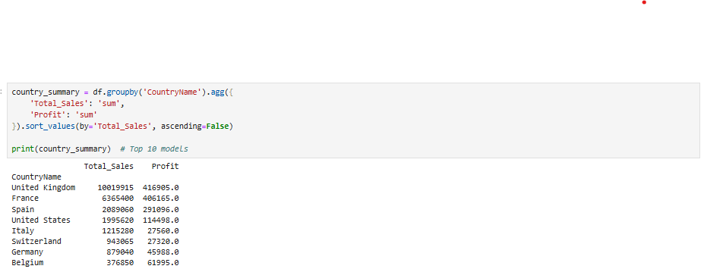**Which regions or locations have the highest sales and profit margins?**

**Answer :**

* **Top Revenue Countries**

United Kingdom is the top-performing market, generating $10.02 million in total sales and leading in profit with $416.9K. This highlights it as a core strategic market.

France is the second-highest in revenue ($6.37M) and nearly matches the UK in profit with $406.2K, indicating excellent cost efficiency and healthy margins.

Spain follows as a mid-tier contributor with $2.09M in sales and a noteworthy profit of $291.1K, suggesting strong returns relative to its size.

United States With $1.99M in sales and $114.5K profit, the U.S. market offers balanced performance but still lags behind Europe’s top markets in terms of profitability ratio. There may be potential for scaling up with margin-focused strategies.

* **High Margin Efficiency**

Belgium, despite having the lowest total sales ($376.9K), yields a surprisingly high profit of $61.9K, suggesting very efficient operations or premium sales in this market.

Spain and France also show strong profitability ratios, making them high-potential markets to reinforce.

* **Low Profitability Markets**

Italy and Switzerland both generate moderate sales ($1.2M and $943K respectively) but return very low profits ($27.6K and $27.3K).

Germany shows moderate efficiency, with $879K in sales and $45.9K profit. Further improvements could unlock higher returns.

**Recommendations:**

* **Strengthen high-value markets like the UK, France, and Spain by expanding offerings and reinforcing marketing efforts.**
* **Re-evaluate pricing and cost structures in Italy and Switzerland to improve profitability.**
* **Explore the Belgium model to replicate its high-margin approach in similar, smaller markets.**
* 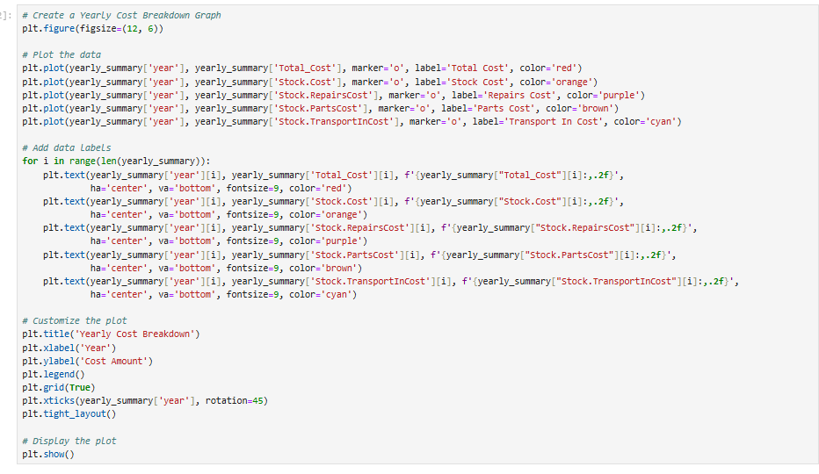**Assess opportunities in the U.S. for expansion while managing costs to improve the profit-to-sales ratio.**
* **Diagnostic Questions (Why did it happen?)**
* A graph with numbers and lines

  AI-generated content may be incorrect.**Why did profit decrease in 2017?**

**Answer :**

**Sharp Increase in Total Costs**

Sharp increase in total cost from $4.18 million (2016) to $6.71 million (2017) due to the sharp increase in stock cost from $3.9 million (2016) to $6.3 million (2017) and decreased to 6.2 million ( 2018) due to cost reductions and improvements .

**Lower Profit Margins**

high-margin vehicles like GBR ( Aston Martin , Bently , Rolls Royce and Jaguar ) and Italy cars ( Ferrari , Lamborghini and Alfa Romeo ) which record total sales of 19.7 million and total profit of 4.2 million were sold in 2016 ( 87 cars with 5.3 million total sales and 1.5 million profit ) , in 2017 ( decreased to 72 cars with 6.4 million total sales and 1.1 million profit ) and 2018 ( increased to 96 cars with 6.6 total sales and 1.3 million profit )

**The reduction in the number of high-margin units sold in 2017 had a notable impact on overall profitability.**

**Increased Operational or Marketing Expenses**

Investment in expansion, advertising, or staffing may have inflated expenses without immediate ROI

**Regional Performance Impact**

If growth was driven in regions with lower profit contribution or higher costs (e.g., increased shipping/import costs), overall profit would suffer

1. **Exporting Excel File after analysis From Python**



### Phase 4: SQL Database Integration

**Tools :** Microsoft SQL Server Management Studio

* **A diagram of a company

  AI-generated content may be incorrect.Entity Relationship Diagram**
* **Entities and Relationships**

1. **Entities:**

* **Sales** (Sales-ID, Sale-Date, Customer-ID)
* **Sales-Details** (Sale-Details ID, Sales-ID, Line Item Number, Stock-ID, Sale-Price, Line Item Discount, Total Cost, Total Sales, Profit, Profit Percentages)
* **Customer** (Customer-ID, Customer Name, Customer City, Customer Region)
* **Stock** (Stock-ID, Date Bought, Model-ID)
* **Cars Category** (Make-ID, Make Name, Make Country)
* **Cars Model** (Model-ID, Model Name, Make-ID)

1. **Relationships &Participation :**

* **Sales to Customer**

**Relationship:**

One customer can have many sales (1:M relationship)

**Participation:**

Customer: Partial (a customer might exist without making a sale)

Sales: Total (every sale must have a customer)

* **Sales to Sales Details**

**Relationship:**

One sale can have many sales details (1:M relationship)

**Participation:**

Sales: Total (every sale must have at least one detail)

Sales Details: Total (every detail must belong to a sale)

* **Sales Details to Stock**

**Relationship:**

One stock item can appear in many sales details (1:M relationship)  
**Participation:**

Stock: Partial (a stock item might exist without being sold yet)

Sales Details: Total (every sales detail must reference a stock item)

* **Stock to Cars Model**

**Relationship:**

One car model can have many stock items (1: M relationship)  
**Participation:**

Cars Model: Partial (a model might exist without current stock)

Stock: Total (every stock item must reference a model)

* **Cars Model to Cars Category**

**Relationship:**

One make category can have many models (1: M relationship)  
**Participation:**

Cars Category: Total (every make must have at least one model)

Cars Model: Total (every model must belong to a make)

1. **Mapping :**
2. **Customer**

Customer-ID (PK)

Customer Name

Customer City

Customer Region

1. **Sales**

Sales-ID (PK)

Sale Date

Customer-ID (FK to Customer)

1. **Cars Category**

Make-ID (PK)

Make Name

Make Country

1. **Cars Model**

Model-ID (PK)

Model Name

Make-ID (FK to Cars Category)

1. **Stock**

Stock-ID (PK)

Date Bought

Model-ID (FK to Cars Model)

1. **Sales Details**

Sale Details-ID (PK)

Sales-ID (FK to Sales)

Line Item Number

Stock-ID (FK to Stock)

Sale Price

Line Item Discount

Total Cost

Total Sales

Profit

Profit Percentage

1. **A screenshot of a computer

   AI-generated content may be incorrect.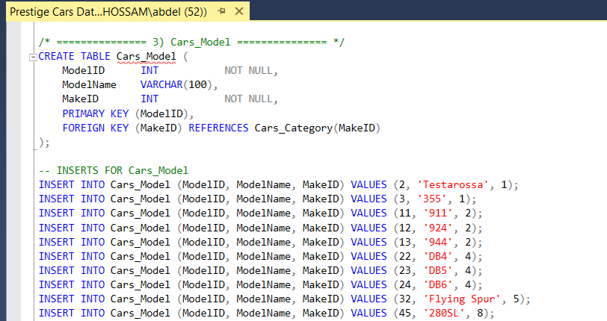A screenshot of a computer

   AI-generated content may be incorrect.A screenshot of a computer

   AI-generated content may be incorrect.Creating Database :**

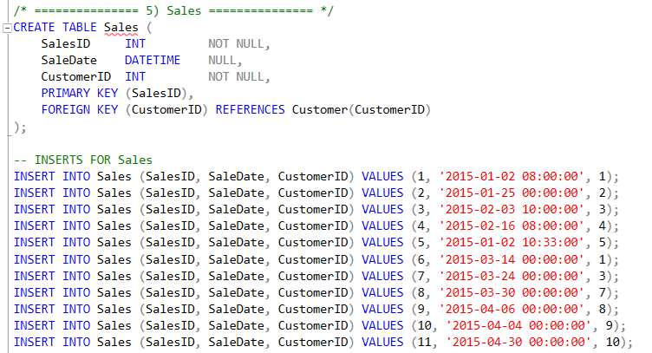

1. 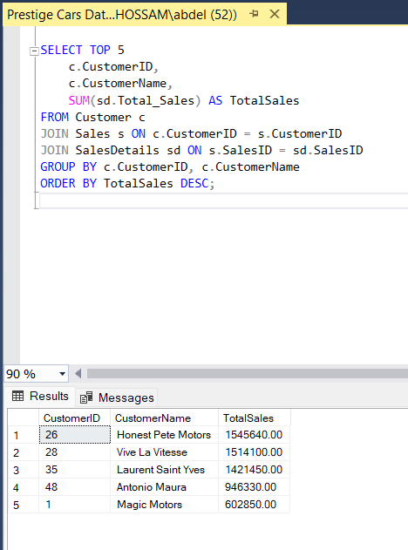**A screenshot of a computer

   AI-generated content may be incorrect.Validation**
2. A screenshot of a computer

   AI-generated content may be incorrect.**Database Diagram**

### 

### Phase 5: Visualization and Reporting

**Tools :** Power BI

### Phase 6: Final Presentation & Submission

* Create a structured presentation.
* Rehearse and refine the delivery.
* Submit the final report and supporting materials.

### 1.5 Task Assignment& Roles

**Each team member had a defined role in the project.**

## Data Collection: Responsible for acquiring and validating data sources.

## Data Cleaning & Processing: Ensuring data accuracy and consistency.

## Analysis & Visualization: Applying statistical methods and creating dashboards.

## Report Generation: Documenting insights and creating presentations.

### 1.6 Risk Assessment & Mitigation

## Data Quality Issues: Addressed by implementing validation techniques.

## Time Constraints: Managed by setting milestones and review checkpoints.

## Technical Challenges: Resolved through collaboration and research.

## 1.7 KPIs (Key Performance Indicators)

* **Sales & Revenue KPIs** (Total Sales Revenue , Sales Growth Rate, Sales by Region, Top Selling Models )
* **Profitability KPIs** (Total Profit , Profit Margin , Model Profitability )
* **Inventory/Stock KPIs** ( Stock Turnover Rate , Days in Inventory , Unsold Stock Value )
* **Customer KPIs** ( Customer Lifetime Value (CLV) , Repeat Purchase Rate , Top Customers by Profit )

### 2. Literature Review

### 2.1 Research Background

Store data analysis is widely used in retail to improve decision-making. Previous studies highlight the importance of sales forecasting, inventory management, and customer behavior analysis.

Various methodologies such as machine learning and statistical analysis have been applied to similar projects.

### 2.2 Feedback & Evaluation

We regularly consulted with our lecturer to get feedback on our approach and methodology. This will help us refine our techniques and ensure our project meets academic and industry standards.

### 2.3 Suggested Improvements

Based on evaluations, we made necessary adjustments to improve our data processing techniques, visualizations, and overall analysis.

### 3. Requirements Gathering

### 3.1 Stakeholder Analysis

* **Sales Manager :** Oversees the sales team and performance
* **Inventory Manager :** Manages stock levels and car availability
* **Finance Department :** Handles budgets, profits, and cost analysis
* **Marketing Team :** Designs campaigns and promotions
* **Management (CEO/COO) :** Strategic decision-makers
* **Customers :** Buyers of prestige cars
* **IT/Data Team :** Maintains the database and reporting systems
* **Car Suppliers / Manufacturers :** Provide vehicles for resale
* **Customer Service :** Supports post-sale queries

### 3.2 User Stories & Use Cases

### Sales Agent

Record a new sale for a customer so that the transaction is tracked in the

Add multiple car items to a single sale so that I can handle bulk purchases.

Apply discounts to line items so I can offer promotional deals.

See the total cost, total sale price, and profit of each sale to quickly assess the transaction value.

### Sales Manager

Generate reports showing total sales and profit by car make, model, and country so I can identify high-performing brands.

Track sales by customer region and city to understand market distribution.

Analyze profit percentages over time to identify trends and business growth.

Evaluate which customers made the most purchases to offer them loyalty rewards.

### Inventory Staff

Add new stock items by selecting a car model and date bought so I can track inventory accurately.

Update the stock status once a car is sold so that the system reflects availability.

Categorize each car by category (e.g., luxury, sports) so I can organize the catalog.

### Customer

View a catalog of available cars by model and make so that I can select the one I want to purchase.

Purchase history recorded so that I can refer back to past transactions.

### System Admin / Data Analyst

Calculate the profit and profit percentage for each sale so I can perform ROI analysis.

Ensure that each stock item links correctly to a car model and that each sale is tied to a customer.

### 3.3 Functional Requirements

The system includes features such as:

* Data import and export capabilities
* Interactive dashboards for visualization
* Automated trend detection and report generation

### 3.4 Non-functional Requirements

**The System:**

* **Efficient :** Process large datasets quickly
* **Secure:** Protect data from unauthorized access
* **User-friendly:** Provide an intuitive interface
* **Reliable**: Ensure minimal downtime and high availability

### 4. References

* <https://github.com/Hossame-Abdelhady/Final-Project-Files>
* **Data Excel File**
* **Python File**
* **SQL File**
* **Power BI File**
* **Project Documentation**
* **Presentation**